Ornaments as indicators of social changes in northeastern Taiwan before and after European colonial period

Li-Ying Wang

Ben Marwick

15 December, 2019

Long-lasting indirect impacts on indigenous peoples in the periphery of colonial control are poorly understood, especially in East Asia. Trade ornaments from Kiwulan (1400-1900 AD) in northeastern Taiwan show the indirect impacts of European colonial activities on local societies. The diversity of ornaments was greater during the period of European presence compared to previous periods, and their spatial distribution was more clustered. This hints at increasing social inequality resulting from colonial influence. Ornaments give insights into the increasing social inequality stimulated by European colonization, and show the agency of indigenous people to incorporate ornaments into their social system.

# Introduction

The direct impacts of European colonialism on indigenous communities in East Asia were much less conspicuous than in island Southeast Asia and Oceania. Direct European colonial rule throughout East Asia was rare and limited, and the question of long-lasting indirect impacts on local indigenous communities remains largely unanswered. Understanding the indirect effects of colonialism are important for detecting colonial impacts on indigenous peoples in the periphery of colonial control (Trabert 2017). In many parts of the world, the introduction of foreign trade goods by colonial traders into local indigenous societies caused substantial transformations of indigenous economic, cultural, and socio-political systems (Dietler 2005; Dietler 1997; Junker 1993; Silliman 2005). Consumption patterns of foreign goods can give insights into negotiations between colonized and colonizer, and the resistance and accommodations of indigenous people through their daily cultural practices (Dietler 2015; Given 2004; Mullins 2011; Scaramelli & Scaramelli 2005; Silliman 2001; Torrence & Clarke 2000; Voss 2005). Northeastern Taiwan is an ideal context to study peripheral colonial influence because although there was a prominent Spanish and Dutch colonial presence in parts of Taiwan, the northeastern region was isolated from intensive direct contact by the Xueshan Mountains.

This article describes personal ornaments excavated from the upper component of Kiwulan (1400 AD-1900 AD), the largest Iron Age settlement on the Yilan plain in northeastern Taiwan. The first recorded European presence in Yilan was a Spanish revenge attack on indigenous villages in 1632 (Borao 2001: 163). In 1647 the Dutch attacked villages and forced them to accept colonial rules and pay an annual tribute (Andrade 2007). According to Dutch census reports in 1650, Kiwulan was the largest indigenous settlement in the plain, with a population of 840 adults (Nakamura 1938: 12). Following defeat of Dutch by the Chinese general Koxinga in 1661-1662, the Dutch abandoned northern Taiwan. Direct contact with Han Chinese is indicated by Qing dynasty census reports mentioning Yilan villages in 1821 (Yao 1996).

One of the most commonly traded types of object in this region were ornaments such as glass and stone beads (Chen 2007; Li & Chiu 2014; National Musuem of Taiwan History 2005). Personal adornments in the archaeological record are useful as signal of an individual’s status (Joyce 2005; Scaramelli & Scaramelli 2005). The consumption of stone beads in Southeast Asia during Iron Age is often associated with increasing social stratification or socio-political complexity (Bellina 2014; Carter 2016; Francis 2002; Theunissen *et al.* 2000; Kenoyer 2000). In this paper, we explore archaeological ornaments from Kiwulan spanning the pre-European contact period, the period of Spanish and Dutch presence, and the following period of Chinese presence. We address the question of whether indirect colonial influences on the indigenous populations can be detected through the ornament assemblages.

# Ornaments in complex exchange network during the late Iron Age and early historical period

The island of Taiwan lies at the junction of mainland China, Southeast Asia, and Northeast Asia in the Pacific Ocean. The prehistory of Taiwan island could be roughly divided into three major periods, palaeolithic (c. 27,000 BP- 5000BP), Neolithic (c. 6500- 2000BP), and Iron age (c. 2000- 400BP) with slightly regional differences in onset of each period and variations in style of artifacts and assemblages (Liu 2011; Chen 2017). It is generally accepted that Taiwan entered the historical period in the early 17th century due to the colonial activities of the Spanish and the Dutch who played an important role in keeping written records about Taiwan. The European colonial presence in Taiwan ended in 1662 when the Dutch were defeated by the kingdom of Tungning, founded by Koxinga from China. Later in 1683, Taiwan was incorporated into the Qing dynasty in China and a large wave of Han Chinese migrated to Taiwan during the late 18th century. Because of natural safe harbors, northeastern Taiwan was involved in a regional trade network through cross-culture interactions with Chinese merchants since the 14th century, and later the global trade network with the Europeans in the 17th century brought more trade goods circulated in Southeast Asia into Taiwan (Chen 2005; Liu & Wang 2017). Although located on the periphery of regional trade centers, Yilan was connected to trade networks via visits of other indigenous groups, Chinese merchants, and Europeans, via sea.

The European presence in northern Taiwan started with the Spanish who founded Fort San Salvador at Keelung in 1626, and Fort San Domingo in 1629 at Tamsui. They sent missionaries to local indigenous settlements in this region (Blussé & Everts 2000: 343) and kept records about their observations of indigenous communities. A Dominican priest in 1632 reported that the Taparri, an indigenous tribe from northern Taiwan, exchanged carnelian beads with other indigenous groups. This form of exchange was widespread and even the Spanish soldiers used carnelian beads as bargaining chips for gambling (Li & Wu 2006: 132–49). The use of beads as prestige goods is further indicated by their role in bride price payments, and compensation to resolve disputes (Li & Wu 2006: 132–49). Other records mention that the female shamans in the tribe would use carnelian beads as magical items in ritual healing practices (Borao 2009: 122–51). Records of an indigenous funeral document the use of carnelian beads in ritual contexts, with more carnelian beads, pottery, and cloth placed into the graves of more influential people to indicate their family’s higher status (Li & Wu 2006: 153). While a full critical analysis of these historical accounts remains to be produced, we take them to minimally indicate that carnelian beads were already treated as prestige goods in Yilan before the arrival of Europeans. In 1642, the Dutch Vereenigde Oostindische Compagnie (VOC) defeated the Spanish and took over their forts in northern Taiwan. They introduced a feudal system in an attempt to control the indigenous communities by asking indigenous leaders to attend an annual ceremony for demonstrating their loyalty and paying tributes (Andrade 2007, ch. 9; Kang 2016, ch. 4). The Dutch provided beads and other goods based on negotations with indigenous communities to secure alliances in the annual ceremony or during travelling (Kang 2016, ch. 6). We might predict that the activities of the Dutch feudal system to build and maintain alliances resulted in an increase in the amount and diversity of ornaments in northeastern indigenous communities during this period.

Chinese historical records from 1829, 1837, and 1852 during the Qing dynasty (1616-1911) contain some notes on the purposes of ornaments from Yilan (Chen 1963: 228, 308; Ke 1993: 11, 126; Yao 1996: 77). According to those records, indigenous people in Yilan wore ornaments in ceremonial contexts to display their wealth and status. Among those ornaments, fish-shaped necklaces made of metal threads had high value due to their delicacy and the exotic materials invested in production. These were usually possessed by wealthy people. Other people wore carnelian beads or glass beads on their head or neck to participate in ceremonies. In 1895, at the beginning of Japanese colonization, an academic field survey for plains indigenous groups reported that fish-shaped metal necklaces necklaces were not used in Yilan at that time, but elderly people still used beads (Ino 1996: 227–32). Although these historical records are fragmentary and may contain some biases (Galloway 2006) that have not yet been studied in detail, we find consistency among multiple sources in their descriptions of how ornaments represent high status or specialized social roles in indigenous communities in Yilan. Compared to the European period, there are fewer documentary mentions of beads in the Chinese period and the descriptions are limited to clothing, but these generally confirm the role of beads as status markers.

Ornaments found in northeastern Taiwan in the early historical period, including glass beads, stone beads, and metal ornaments, are considered to have been imported from other regions. This is because of to a lack of archaeological evidence of beadmaking waste, metalworking, or accessible local raw materials. The chemical composition of glass beads from this region shows a high content of lead and, toghether with the winding/folding technique, these details suggest a Chinese beadmaking tradition (Cheng 2008; Gan *et al.* 2006; Wang 2018). Although there is a wide variety of metal ornaments such as bells, bracelets, rings, and pendants, the common components of metal ornaments are brass and copper, with a small number made from lead and tin that indicates multiple origins that include Southeast Asia (Chen 2011). There is no direct evidence showing European delivery of beads, however, a large amount of the glass beads containing gold foil (hereafter, gold-foil beads) at Kiwulan might have been introduced by the Spanish through economic activities because similar beads were found at Luzon, northern Philippines, as part of the trading route of the Spanish between 16-19th century (Wang & Liu 2007). Both archaeological evidence and historical records indicate northeastern Taiwan was involved in regional networks with East Asia in the late Iron age. These included Chinese merchants trading metal items, clothes, and beads with local indigenous people in Taiwan in exchange for local resources. The foreign-made large dark brown glazed stoneware jars frequently found in European shipwrecks were also commonly found from many sites in Taiwan, suggesting direct or indirect interactions. Despite the Chinese origin of some ornaments at Kiwulan, there is compelling evidence that a large amount of ornaments found at 17th century sites resulted from European colonial and economic activities in the region.

# Excavations at Kiwulan in northeastern Taiwan



Figure 1: Map showing the location of Kiwulan, and other places in northern Taiwan named in the text. Map data from naturalearthdata.com

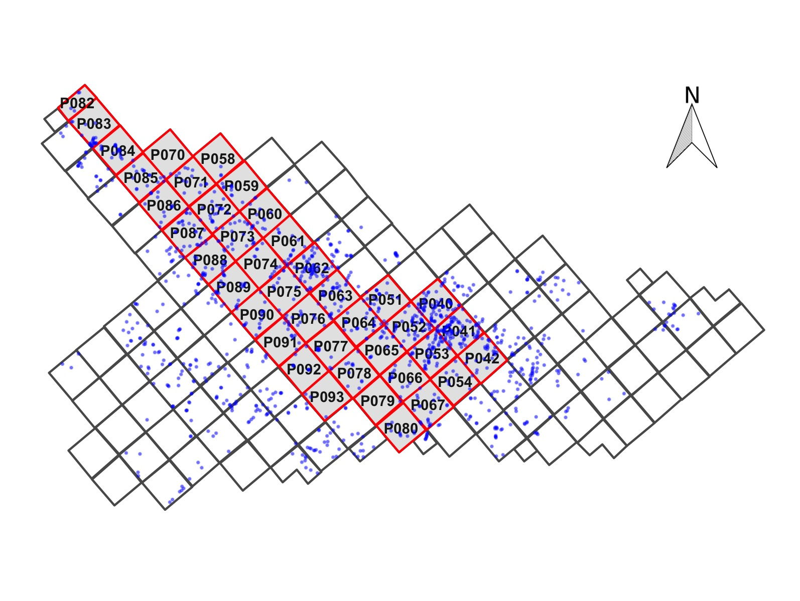

Figure 2: Map showing the largest section of excavation areas at Kiwulan, and the distribution of forty squares sampled in this paper presented in red with square ID number. Small dots represent the location of post-holes. Each square is 4 x 4 m

Information about Kiwulan (Figure 1) comes from a rescue archaeology project that during 2001-2004 in advance of a water diversion project and road bridge construction. The excavations used 2 mm and 1.5 mm mesh screens and covered eight open area sections in total of 262 squares (4 m by 4 m) reaching 3,814 m2 (Chen 2007). The nearly 2 m thick archaeological deposits reveal a large amount of artifacts, burials, middens, post-holes, wooden pillars, and stone structures, all of which indicates it was a long-term settlement. Artifact locations were recorded to the 2 x 2 m sub-square they were recovered in; they lack individual point provenance. Based on the continuity of deposition and the frequency of artifacts, the center of the site is the open area consisting of A and D sections, which is also the study area where our samples selected from. In the AD area, post-holes were found aligned in a north-south direction in some intervals with construction marks, which were interpreted as the remains of silt house structures. At the north margin of the dwelling place were burials that are mostly oriented in an east-west direction (Figure 2).

The chronology of Kiwulan can be divided into two phases represented by a upper component (1400-1900 AD, 600-100 BP) and a lower component (700-1200 AD, 1200-800 BP) separated by a sterile deposit spanning c. 150 years. These component divisions are based on the differences in the colour and texture of the deposit. The interpretation of the sterile deposit is still under debate, with pollen analysis suggesting dry weather leading to site abandonment (Lin 2015; Chiu 2004; Chen 2007). There are 32 radiocarbon ages spanning the two components, previously published by Chen (2007), and shown here in Figure 3 and Table 1. We focus on the upper component because only this component spans the periods of pre-European contact, European presence, and Chinese presence. In the upper component, all excavation squares in our sampling area show signs of continuous human occupation during each of the three phases. Previous work divided the upper component into six analytical units, spanning from the 14th century to the 19th century, according to the radiocarbon dates, excavation depth, consistency of contexts, and types of chronologically diagnostic ceramics such as blue and white porcelains (Hsieh 2009; Wang 2011). However, we found some ambiguities in the previous chronology, so to help answer our research question, we re-examined the upper component to devise a new chronology to assign artifacts to the pre-European, European, and the Chinese periods.

The archaeological indicators of the start of the European influence at Kiwulan are the appearance of light grey glazed jars, known as “An-ping” jars in China and Taiwan, and large dark brown glazed stoneware jars that were introduced to Taiwan during the early 17th century. Large dark brown glazed stoneware jars may have been made in Southeast Asia, and are frequently found in European shipwrecks from this period as vessels for transporting water, wine or other liquids on long voyages. The earliest evidence oflight gray glazed jars in this region has been found among the cargo of the Spanish shipwreck *San Diego*, which sunk in 1600 AD (Hsieh 2009; Hsieh 1995). Southeast China is assumed to be the origin of the light gray glazed jars, however these are commonly found at sites in Taiwan that were associated with European activities, such as the Zeelandia fort site in Tainan (Wang & Liu 2007). The jar shapes found at Kiwulan are typical of those found elsewhere in VOC sites occupied during the 17th century (Berrocal *et al.* 2018: 917; Cort 2017: 282; Grave & McNiven 2013; Ketel 2011; Klose & Schrire 2018: 131). We cannot be sure of the exact process that bought them to Kiwulan: they might have been directly imported by Europeans, by Chinese merchants, or by indigenous groups via regional networks in north Taiwan. In any case, the high volume of ceramics transported by Europeans, and their high mobility in shipping trade played an important role in introducing foreign jars to Taiwan. Those jars were widely distributed across the site and can serve as indicators, together with the radiocarbon dates, to identify the excavation units associated with the pre-European period and the start of European influence at Kiwulan. In addition to stoneware jars as indicators of European presence, around 300 pieces of locally made pipes and a few imported pipes were found at Kiwulan. Smoking is likely to have been introduced by Europeans, and we found that the presence of pipes in the archaeological record here is consistent with distributions of glazed jar fragments, which are far more numerous and widespread across the site (n = 1685).

The archaeological signature of the Chinese period at Kiwulan is the large amount and diversity of Chinese porcelains in many forms such as bowls, plates, and cups. Other indicators include opium pipe-bowls and distinctive architectural bricks and tiles used by Chinese (Hsieh 2009). Chinese migrations to Yilan were also recorded in official Chinese records written in the early 19th century recording the first immigrants in 1768 (Chen 1963; Ke 1993).

Figure 3: Summed probability distributions for dates from Kiwulan. The dark line represents the summed probabilities of all radiocarbon ages, and the grey lines in the background are the probabilities of individual ages. Grey rectangles indicate the approximate chronology of the major archaeological components of the deposit. For the upper component, the blue line indicates the start of European presence, while the red line is the Chinese presence. Ages calibrated with the Bchron package (Parnell et al. 2008)

Figure 3: Summed probability distributions for dates from Kiwulan. The dark line represents the summed probabilities of all radiocarbon ages, and the grey lines in the background are the probabilities of individual ages. Grey rectangles indicate the approximate chronology of the major archaeological components of the deposit. For the upper component, the blue line indicates the start of European presence, while the red line is the Chinese presence. Ages calibrated with the Bchron package (Parnell et al. 2008)

Table 1: Radiocarbon ages from charcoal samples excavated from Kiwulan (Chen 2007), calibrated using IntCal13 Atmospheric curve. The codes in the context column refer to the excavator’s feature labels, cf. Chen 2007

|  |  |  |  |  |  |
| --- | --- | --- | --- | --- | --- |
| Lab code | Pit-Layer | Above mean sea level (cm) | Uncalibrated Age BP | Calibrated Age BP (95% credible interval) | Context |
| NTU-3803 | P052-L7 | 0 to -10 | <200 |  | artefact-bearing deposit |
| NTU-3925 | P051-L17 | -36 to -56 | <200 |  | sterile deposit |
| NTU-3943 | P051-L19 | -70 to -90 | <200 |  | sterile deposit |
| NTU-4283 | P063-L12 | -30 to -70 | <200 |  | midden H044 |
| NTU-4293 | P089-L11 | -50 to -70 | <200 |  | artefact-bearing deposit |
| NTU-4305 | P089-L7 | -20 to -30 | <200 |  | artefact-bearing deposit |
| NTU-4322 | P051-L11 | 0 to -40 | <200 |  | midden H026 |
| NTU-4323 | P070-L3 | 20 to -57 | <200 |  | burial M095 |
| NTU-3993 | P041-L7 | -25 to -45 | 250±40 | 4-429 | artefact-bearing deposit |
| NTU-4419 | P162-L3 | -10 to -110 | 280±70 | 11-484 | midden H172 |
| NTU-4311 | P052-L16 | -110 to -130 | 310±100 | 14-511 | artefact-bearing deposit |
| NTU-4320 | P168-L1 | 6 to -51 | 340±100 | 28-527 | midden H193 |
| NTU-4016 | P028-L9 | -44 to -80 | 270±40 | 151-451 | burial M020 |
| NTU-4310 | P018-L2 | -28 to -70 | 360±100 | 82-541 | burial M039 |
| NTU-3791 | P049-L11 | -20 to -30 | 340±30 | 315-482 | artefact-bearing deposit |
| NTU-4292 | P052-L6 | 4 to -56 | 510±75 | 344-648 | burial M009 |
| NTU-4304 | P066-L11 | -40 to -60 | 600±75 | 514-674 | artefact-bearing deposit |
| NTU-4423 | P144-L5 | -10 to -30 | 610±90 | 501-707 | artefact-bearing deposit |
| NTU-4315 | P248-L5 | -100 to -120 | 800±120 | 559-951 | artefact-bearing deposit |
| NTU-3926 | P041-L9 | -70 to -90 | 900±50 | 716-917 | sterile deposit |
| NTU-4421 | P162-L11 | -160 to -180 | 920±70 | 705-953 | artefact-bearing deposit |
| NTU-4319 | P154-L3 | 10 to -10 | 920±105 | 683-1050 | artefact-bearing deposit |
| NTU-4430 | P238-L10 | -130 to -150 | 1020±60 | 794-1057 | sterile deposit |
| NTU-4422 | P237-L4 | -70 to -90 | 1030±80 | 769-1152 | artefact-bearing deposit |
| NTU-3788 | P028-L15 | -130 to -150 | 1050±40 | 904-1050 | artefact-bearing deposit |
| NTU-4428 | P154-L13 | -170 to -180 | 1080±90 | 800-1219 | artefact-bearing deposit |
| NTU-4427 | P246-L8 | -160 to -180 | 1170±70 | 956-1255 | artefact-bearing deposit |
| NTU-4316 | P019-L5 | -100 to -120 | 1190±70 | 968-1264 | burial M066 |
| NTU-3792 | P041-L13 | -150 to -170 | 1240±30 | 1080-1261 | artefact-bearing deposit |
| NTU-4434 | P144-L11 | -130 to -150 | 1480±70 | 1291-1524 | artefact-bearing deposit |
| NTU-4321 | P154-L14 | -180 to -190 | 1870±110 | 1555-2077 | artefact-bearing deposit |

# The personal ornaments

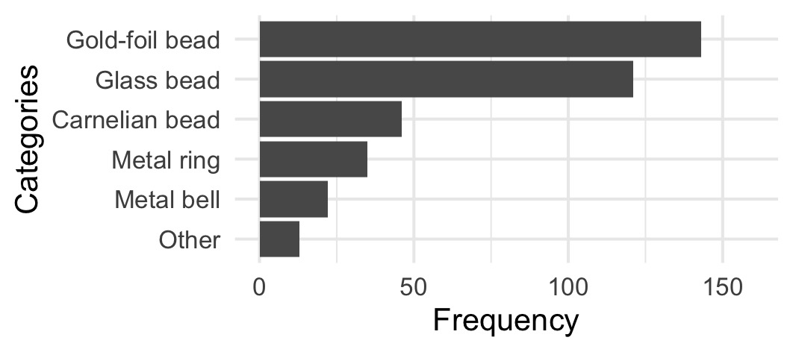

Figure 4: Frequency of the major class of ornaments at Kiwulan. Frequency represents artifact counts

Table 2: Ornament subtype at Kiwulan. The numbers represent artifact counts

|  |  |  |  |  |
| --- | --- | --- | --- | --- |
| Categories | Type | Before European Contact | European Presence | Chinese Presence |
| Carnelian bead | hexagonal | 6 | 17 | 5 |
| Carnelian bead | waxy oval | 0 | 4 | 0 |
| Carnelian bead | small oval | 3 | 3 | 0 |
| Carnelian bead | globular | 0 | 1 | 0 |
| Carnelian bead | pentagonal | 0 | 1 | 0 |
| Carnelian bead | big oval | 0 | 0 | 1 |
| Carnelian bead | long bicone | 0 | 0 | 1 |
| Carnelian bead | octagonal | 0 | 0 | 1 |
| Glass bead | small (0.5-1 cm) | 60 | 37 | 1 |
| Glass bead | medium (1-2 cm) | 8 | 15 | 0 |
| Gold-foil bead | NA | 48 | 93 | 2 |
| Metal bell | large | 3 | 8 | 3 |
| Metal bell | plain small | 0 | 4 | 1 |
| Metal bell | thin small | 0 | 1 | 1 |
| Metal ring | wide small | 1 | 9 | 1 |
| Metal ring | thin large | 4 | 5 | 2 |
| Metal ring | wide large | 0 | 5 | 0 |
| Metal ring | overlapped | 0 | 2 | 0 |
| Metal ring | braid | 0 | 1 | 0 |
| Metal ring | entwined | 1 | 1 | 0 |
| Metal ring | flat | 0 | 1 | 0 |
| Metal ring | large thick string | 0 | 1 | 0 |
| Metal ring | small thin string | 0 | 1 | 0 |



Figure 5: Subtypes of ornament in each major class. A: carnelian beads, B: bells, C: glass beads and gold-foil beads, D: metal rings. Photographs are presented in the same order as those subtypes in the table but from left to right instead. The photographs of B, C, D classes were from original excavation report (Chen 2007)

Ornaments were found in a variety of archaeological contexts including post-holes area, burials, and middens. This study focuses on 406 ornaments from 40 sampling squares located at the dwelling place of Kiwulan, indicated by aligned post-holes with *in-situ* posts (Figure 2). Occupation floors were not identified during excavation. We choose these units because they were stratigraphically intact and undisturbed by modern construction activity, compared to excavation squares on the periphery of the site. There are 35 burials in the sampling area, one third of the total number of burials at Kiwulan. Ornaments are commonly used as grave goods in burials, with the total number of ornaments in burials including 3,173. The high number of ornaments in these burials is due to the presence of bead strands or patterned bands of beads, which sometimes contains thousands of beads in an individual burial (Chen 2007). We exclude burials from this analysis because most of them date to the pre-European period (n = 26), limiting the usefulness of comparisons between the periods. In addition to 406 ornaments from dwelling place contexts and 3,173 from burial contexts, there are 27 ornaments found in midden contexts. We focus on ornaments from the dwelling place contexts (Figure 4, Table 2) because these give us the greatest spatial and temporal representation across the three time periods, and so are most informative on social inequality indicated by uneven distributions of ornaments. # Reproducibility and open source materials

To enable re-use of materials and improve reproducibility and transparency (Marwick 2017), the entire R code (R Core Team 2019) used for all the analysis and visualizations contained in this paper is included in <http://doi.org/10.17605/OSF.IO/R8YGA>. Also in this version-controlled compendium (Marwick *et al.* 2018) are the raw data for all the visualizations and tests reported here. All of the figures, tables, and statistical test results presented here can be independently reproduced with the code and data in this repository. The code is released under the MIT license, the data as CC-0, and figures as CC-BY, to enable maximum re-use.

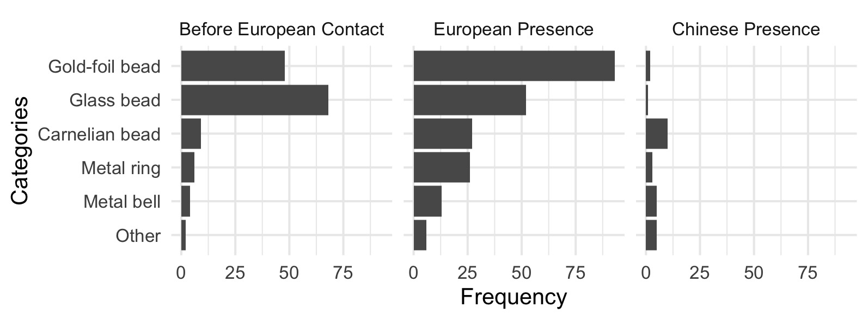

Figure 6: Frequency of the major ornament across different time periods

# Results

## Changes in the frequencies of ornament types over time

Figure 6 shows the comparison of frequencies of the major classes of ornaments for different time periods at Kiwulan. The difference in frequencies between the three time periods reflect significant differences in the use of ornaments (chi-square = 71.82, df = 8, p-value = $2.14×{10}^{−12}$). Most ornament types were present before European contact. Ornament frequencies reached a peak during the European period and then dropped during the Chinese period, especially gold-foil beads. This trend can be also seen on other ornaments including carnelian beads, metal rings, and bells. However, glass beads show a different pattern that indicates a higher frequency in the pre-European contact, and then a decrease in the European period and a further decrease in the Chinese period. To model the number of ornaments as a function of the mass of ceramics in each period, a Poisson GLM with a log link function was used. The model reveals that ceramic abundance strongly predicts the number of ornaments (β = $1.94×{10}^{−5}$, p = $4.225×{10}^{−29}$). If ceramic abundance is a suitable proxy for population at Kiuwan due to its basic role as cooking vessels, then ornament quantities per period may be influenced by the number of people living at the site.

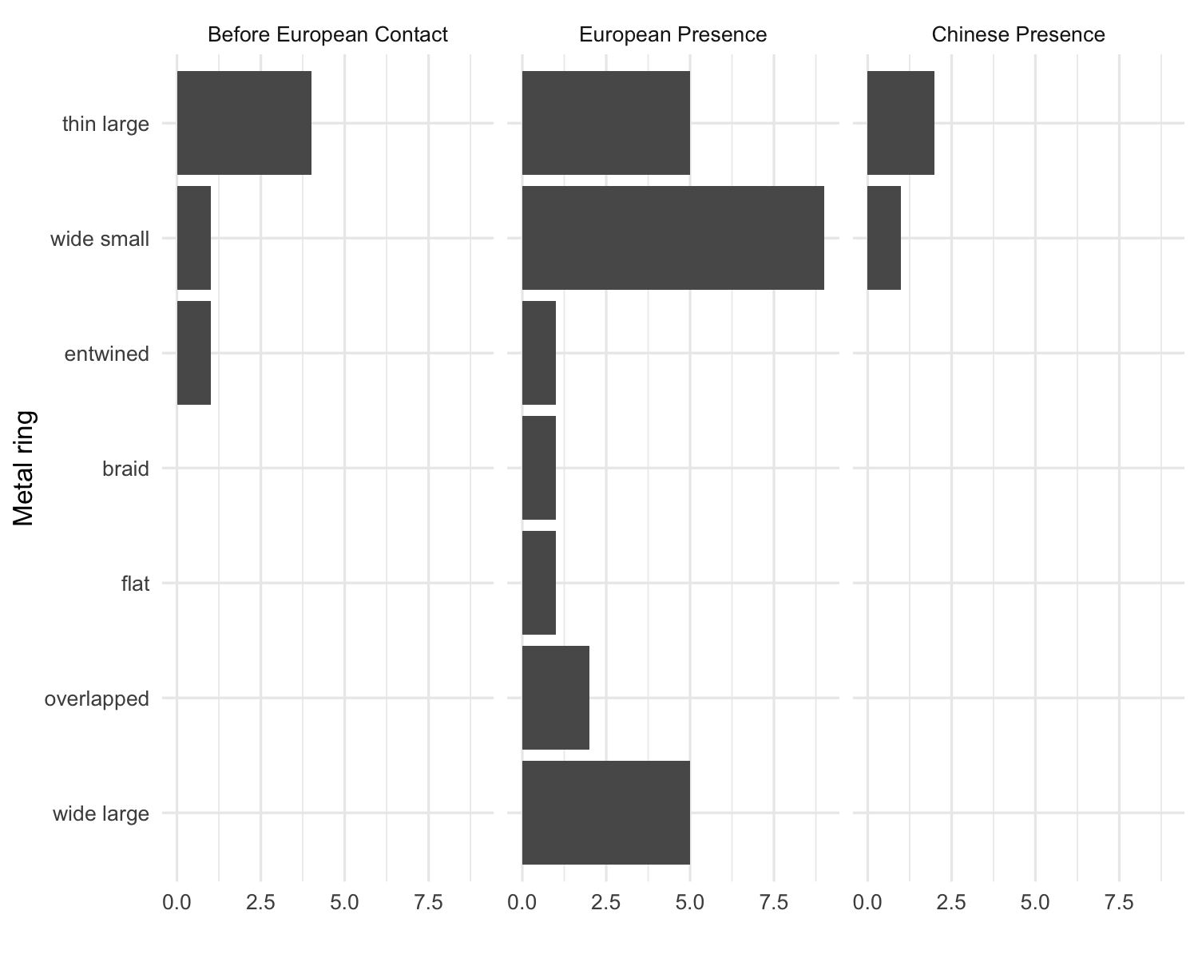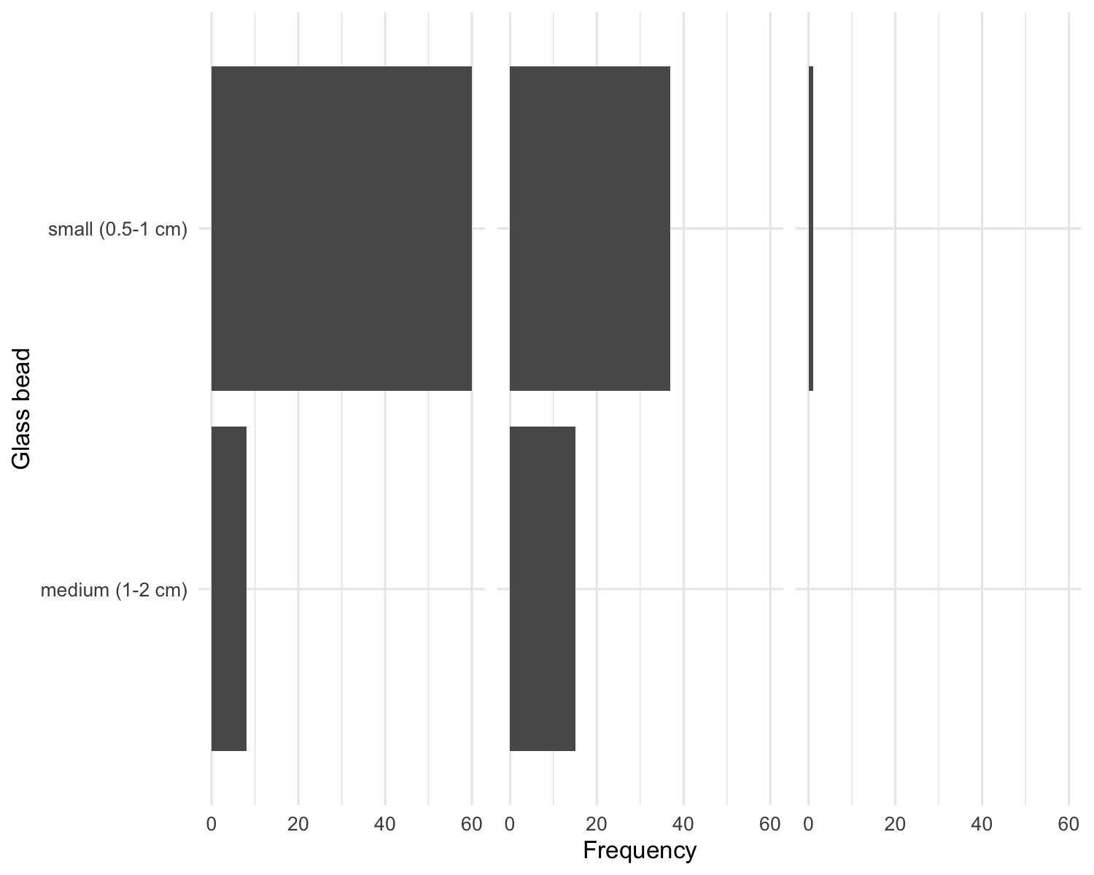

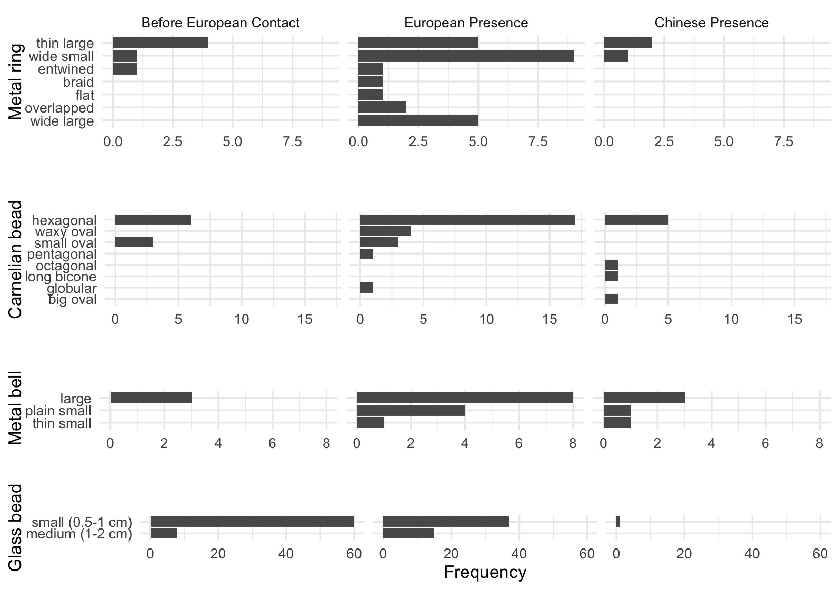

Figure 7: Frequency of ornament subtypes showing the changes in frequency across time periods for metal rings, carnelian beads, bells, and glass beads

The distribution of frequencies for subtypes in each major class is presented in Figure 7. Spearman’s correlation test shows that there is no significant relationship between diversity of subtypes and sample size (S = 173.16, rho = 0.39, p = $0.20438$). This indicates that the increases in diversity can be explained by the effects of culture interaction instead of the effects of sample size. Carnelian beads and metal rings have greater quantity and variety of shapes compared to copper bells and glass beads during the European period. The greater varieties for carnelian beads and metal rings might indicate multiple origins due to participation in large scale trade networks stimulated by the European presence. In contrast, copper bells have less variety typically >2 cm long with a wide variety of human faces as a motif. Although glass beads have less variety in size, small (0.5-1 cm) and medium (1-2 cm), they have a wide variety of colors or patterns mostly made by winding technique with high lead content in composition indicating possibly from China (Cheng 2008). Although we are not certain of the specific origin of these beads, research suggest that these glass beads and metal ornaments have similar production techniques and composition to those found in China (Chen 2011; Wang 2018). There seem to be no obvious changes in the sources of glass beads or metal ornaments at different periods in the upper component of Kiwulan (1400-1900 AD). However, the glass beads found from the lower component (700-1200 AD) are mostly Indo-Pacific beads, widespread in Southeast Asian sites since 300 BC and declining during the early 2nd millennium (Wang 2018; Francis 2002).

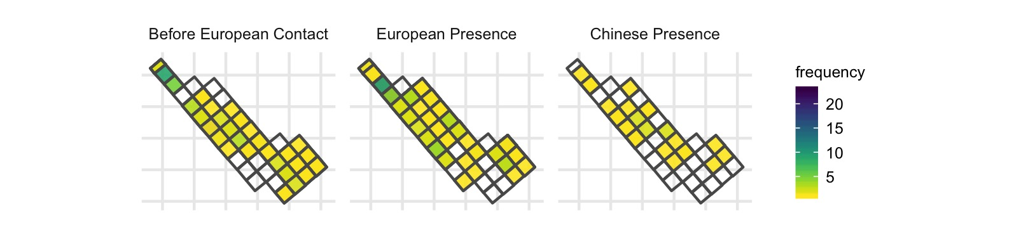

Figure 8: Spatial pattern of all class of ornament by time periods

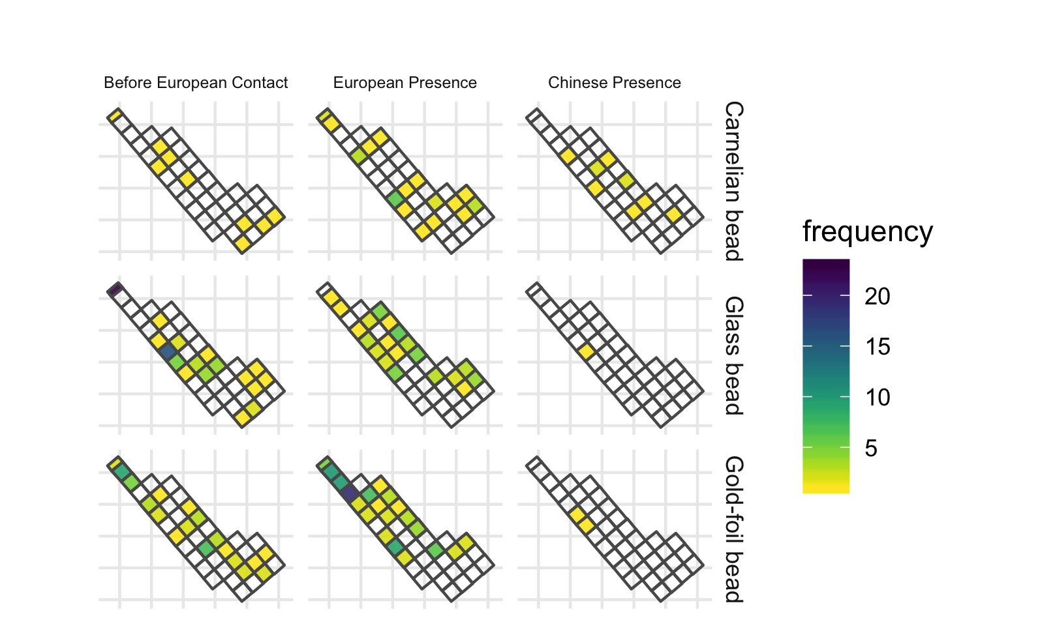

Figure 9: Spatial pattern for ornament class by time periods, only those types with more than 5 pieces are shown here

## Changes in patterns of the spatial distribution of ornament types

Figure 8 presents the spatial distribution of all ornaments from the research area for each time period. Before the European arrival, a greater amount of ornaments were found at the northern and middle parts of the research area. During the European period, ornaments were more widespread, with some clusters on the northern part. During the Chinese period the distribution is more even again. Figure 9 presents the distribution for the major ornament classes individually, some clusters across the area can be observed during the European period, such as gold-foil beads and carnelian beads. However, there seems to be no consistent pattern across those different ornaments. Each class shows its own pattern where the squares with higher numbers of ornaments distributed separately and independently. For example, a cluster of gold-foil beads was found at the northern part, while a cluster of carnelian beads was found in the middle part. In contrast, there are multiple clusters of metal rings that are distributed separately across the research area. Copper bells were usually found individually and appear randomly distributed across the area. In the Chinese period, both the amount and density of different classes of ornaments decreased.

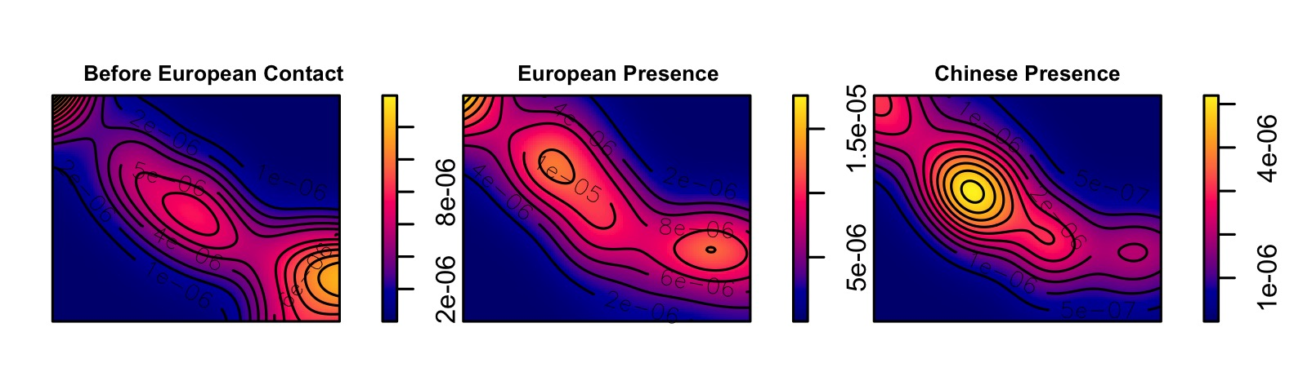

Figure 10: Kernel density map for ornaments by periods. Used the bandwidth based on Silverman (1986)’s rule of thumb

## Point pattern analysis of ornament distribution

Point pattern analysis can assess whether the distribution of artifacts represents hotspots produced by non-random processes (Bevan & Lake 2016; Ducke 2015), such as concentrations of ornaments in specific households that might result from social inequality stimulated by a colonial presence. To prepare the ornament location data for point pattern analysis, because artifacts from Kiwulan lack exact piece-provance data, we assigned each ornament to a random coordinate pair in the square it was recovered from. The next step was to divide the ornaments into three time periods. Finally we computed the kernel densities for each time period for comparison. Kernel density estimations (KDE) compute the probability of the density of ornaments across space by creating a continuous, smooth density surface across space. Here we use KDE to visualize core areas of ornaments and surrounding neighbourhoods (Bonnier *et al.* 2019; Cortegoso *et al.* 2016). Density values of artifacts per square meter were calculated for each cell.

Figure 10 shows that there is one major core area during the pre-European period, multiple core areas during the European period, and a single core during the Chinese period. There are three consistent sub-regions with a core area that shifts over time. The distribution might indicate the increase and decrease in the number of social groups who possessed ornaments. The multiple groups during the European period might reflect unequal consumption of ornaments across the site, relative to other periods, or random patterns resulting from a bigger sample size. In addition, the generation of core areas might be biased due to small sample sizes, for example, a few ornaments found at one single square during the Chinese period could create an obvious hotspot. Whether the observed clustering is random or non-random is crucial for the interpretation of intentional human activities.

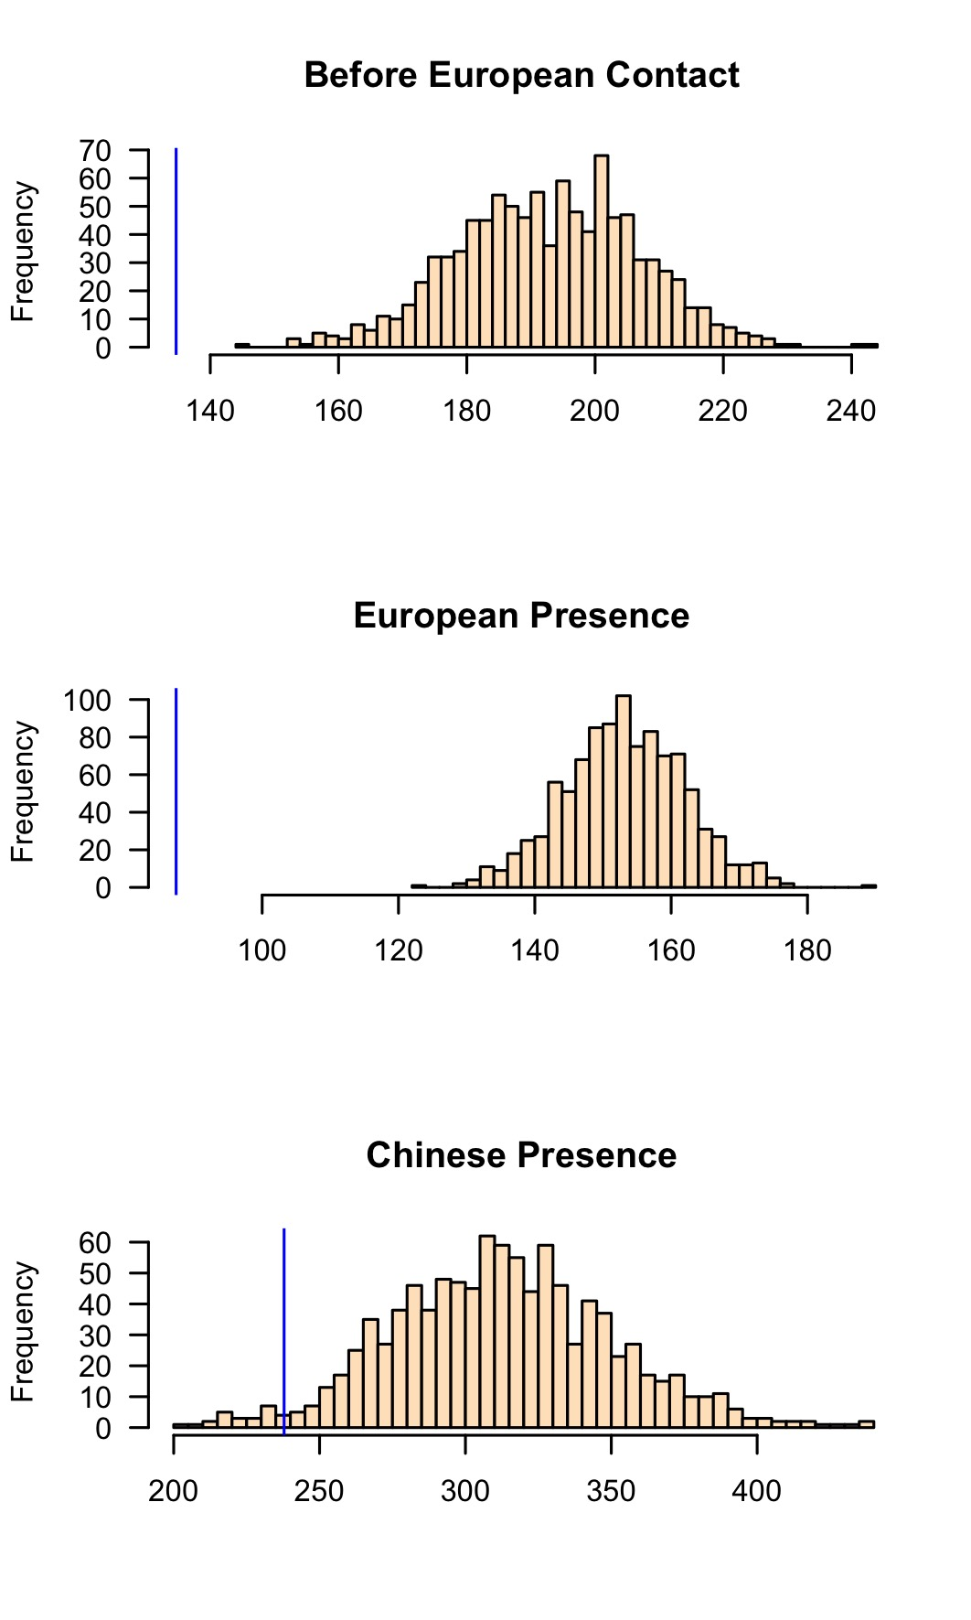

Figure 11: Histograms of simulated ANN values from 1000 simulations for three time periods. X-axis values represent ANN expected value under a completely random process resulted from simulated pattern. Each sample distribution presents the null hypothesis with the blue line indicating the observed ANN value

To test for randomness in spatial locations, we used a Monte Carlo method to simulate average nearest-neighbour distances (ANN). Figure 11 shows the observed ANN distances with the distributions of the ANN distances calculated on 1000 simulations of random ornament locations. The results show that 100% of the simulated values are much greater than our observed ANN value during the European period, which means the ornaments have non-randomly clustered distributions. A similar, but less extreme, result is also observed during the pre-European period. The observed distribution of ornaments is more similar to the random distributions during the Chinese period, with about one third of the simulated values are greater than our observed ANN value. The Chinese period has fewer artifacts in any category, likely reflecting a smaller population at Kiwulan at this time, making spatial patterns and hotspots difficult to discern with confidence. This testing reveals clustering of ornaments during the European period is highly non-random, potentially indicating different degrees of access to foreign ornaments or a concentration of power to control the distribution of ornaments at Kiwulan during this period.

# Discussion

An indirect colonial influence may be indicated at Kiwulan by the greater diversity of ornament types and materials during the European period. Yilan was involved in complex trading networks both on a regional scale with other indigenous groups and Chinese merchants, and at a global scale with Europeans, including the Dutch and the Spanish. The ornaments have multiple origins, including Southeast Asia and China, and were first introduced into northeastern Taiwan by Chinese merchants before 17th century. Later, trade activities became more frequent and intense in the 17th century due to European activities. The greater diversity and quantity of ornaments likely results from participation in large scale exchange networks that stimulated the circulation of different ornament classes. The frequency of overall ornaments and each subtype declines significantly after European influence fades during the Chinese period in the early 19th century. This may be due to a smaller scale of trading networks, the overall decline of indigenous populations in Yilan, or the adoption of Han Chinese practices. The decline of the population may be related to the movement of many indigenous people moved southwards to Hualien due to population pressure caused by Han Chinese immigrants at the end of the 18th century (Chen 2007).

Archaeological contexts show that ornaments are especially abundant in burial contexts serving as grave goods. This supports the interpretation of ornaments as valuable objects functioning as status indicators. Spatial patterns of ornaments in dwelling contexts show that their distribution was clustered during the pre-European and European periods. These clusters are non-random, and are most highly concentrated during the European period. This may indicate that a degree of social inequality based on the uneven distribution of ornaments was already present before European contact, and then it was reinforced and amplified during the European period. A further indicator of increased social inequality is a burial dated to the 17th century that included 60 gold-foil beads, well above the average of 2-3 pieces in the pre-European period (Chen 2007; Cheng 2008).

How might these results fit into a bigger picture of social change at periphery of colonial systems? We may get some insight into the general pathways that led to social inequality in northeastern Taiwan by considering how people have achieved and maintained power in a wide variety of societies (Drennan *et al.* 2010; Feinman 2000; Ames 2010; Bowles *et al.* 2010). The corporate/network model proposed by Feinman (2000) expands traditional hierarchical complexity to provide a comparative basis for distinct strategies for power. In the network mode, inequality develops when individuals accumulate wealth through their individual networks and people use their wealth to attract factions, control resources, and monopolize trade networks. In contrast, the corporate mode stresses shared power across different groups and sectors, integrative ceremonies and rituals, and large cooperative labour tasks (Feinman 2000; Siegel 1999). We may be able to interprete Yilan social organization as moving from corporate mode before the European arrival, to a network mode during European presence. The small number of ornaments, and less concentrated distribution during the pre-European period appears consistent with shared power and wealth of the corporate mode. The long-distance trade network introduced by Europeans resulted in the appearance of a network mode, and the emergence of competition among ambitious individuals for prestige, wealth, or power through collecting trade goods (Brumfiel 1994; Clark & Blake 1994). Because of the weak direct control from the European colonizers in northeastern Taiwan, local leaders may have had the flexibility to manipulate European colonial images, expand personal power, and monopolize the high-value trade goods (Kang 2012).

That said, the evidence from Kiwulan may be consistent with a variety of scenarios of indigenous-colonial relations. The increasing number and concentrated spatial patterns of ornaments may indicate a practice of cultural resistance against the European intrusion. Resistance to European economic and political demands may be inferred if ornaments were used as a display of social identity and to emphasize the local customs that had existed before European contact (cf. Rubertone 2000). Resistance could be presented in many forms. Another scenario is that ornaments were treated as heirlooms, such as carnelian beads and gold-foil beads, that passed from one generation to the next, accumulating at Kiwulan over time. This process would result in a natural increase in ornaments over time, unrelated to colonial influences, but has limited value in explaining the shifts in spatial patterns.

# Conclusion

Examination of the archaeological record at the peripheries of colonial activities can show how remote indeignous groups were affected by major European colonial processes (Trabert 2017). Kiwulan in northeastern Taiwan is an exceptional case study as an East Asian location that was relatively isolated and peripheral, and yet connected by regional and global trade networks. Kiwulan provides valuable insights into the discussion of indirect colonial influence on local societies living beyond the borders of direct European colonial occupation. The frequency and spatial distribution of personal ornaments at Kiwulan present three distinct patterns during different dominant culture interaction periods. The greater amount and diversity of ornament types during the European period reflects an increasing use in ornaments in a colonial context. Before European contact, ornaments were traded into local indigenous societies via the regional exchagne network with Chinese merchants and viewed as prestige goods in local indigenous culture according to their distribution in the archaeological contexts. After the arrival of the Europeans, the exotic and powerful image carried by those ornaments may have intensified, further signalling wealth and privileged trading connections among the inhabitants of Kiwulan. This may have stimulated more competition between aggrandizing individuals for prestige and wealth accumulation at Kiwulan, which might have resulted in an increase in social inequality. This might also indicate an act of intentional resistance to the intrusion of the Europeans by using more ornaments that is part of culture tradition.

We are still far from understanding the full variety of colonial impacts on peripheral indigenous communities. The origin of ornaments and how their sources changed over time would give more information to construct a clear picture of complex trade networks during this periods. By focusing on the distribution patterns in a settlement site, the Kiwulan ornaments suggest that foreign ornaments can be a proxy to detect indirect colonial influence on local indigenous populations. Ornaments give insights into the amplification of social inequality stimulated by European colonization. It also shows the agency of indigenous people to incorporate ornaments into their social system and use them in their daily lives to display or intensify status differences. Future work could extend this approach to sourcing the ornaments directly with geochemical methods, and studies of other trade goods such as ceramics. We have introduced here the corporate/network model for understanding the dynamics of social inequality at Kiwulan, and future tests of this should include analysis of pottery production and standardization, and mortuary practices.

# Acknowledgements

We would like to thank the Yilan County Cultural Affairs Bureau in Taiwan for permitting access to the ornaments used in this study. We thank Shui-jin Chiu, Shu-hui Jian, Jiun-yao Lai, and the staff in archaeology lab for their invaluable assistance in preparing samples for analysis. We also thank Yu-pei Chen for the discussion regarding the site at the earliest stage of fieldwork. This work was supported in part by the Fritz Graduate Fellowship and travel grants from the Department of Anthropology at University of Washington. We would also like to thank Ben Fitzhugh and Peter Lape for their insightful comments on the early draft.

##### pagebreak

# References

Ames, K.M. 2010. On the evolution of the human capacity for inequality and/or egalitarianism, in G. Feinman & T.D. Price (ed.) *Pathways to power: New perspectives on the emergence of social inequality*: 15–44. New York: Springer.

Andrade, T. 2007. *How Taiwan became chinese : Dutch, spanish, and han colonization in the seventeenth century*. New York: Columbia University Press.

Bellina, B. 2014. Maritime silk roads’ ornament industries: Socio-political practices and cultural transfers in the south china sea *Cambridge Archaeological Journal* 24. Cambridge University Press: 345–77.

Berrocal, M.C., E.S. Herrero., M.G. Moret., A.U. González., M.T. Pérez., S.C. Rodrı́guez., A. Chevalier., F. Valentin. & C.-h. Tsang. 2018. A comprised archaeological history of taiwan through the long-term record of heping dao, keelung *International Journal of Historical Archaeology* 22. Springer: 905–40.

Bevan, A. & M. Lake. 2016. Intensities, interactions, and uncertainties: Some new approaches to archaeological distributions, in A. Bevan & M. Lake (ed.) *Computational approaches to archaeological spaces*: 27–52. Routledge.

Blussé, L. & N. Everts. 2000. *(FEII) the formosan encounter. Notes on formosa’s aboriginal society, a selection of documents from dutch archival sources. Volume ii: 1636-1645*. Taipei: Shung Ye Museum of Formosan Aborigines, Taipei.

Bonnier, A., M. Finné. & E. Weiberg. 2019. Examining land-use through gis-based kernel density estimation: A re-evaluation of legacy data from the berbati-limnes survey *Journal of Field Archaeology* 44. Taylor & Francis: 70–83.

Borao, H., J. E. 2001. *(SIT, pp. 1-343). Spaniards in taiwan, vol. I (1582–1641)*. Taipei: SMC Publishing.

Borao, J.E. 2009. *The spanish experience in Taiwan, 1626-1642: The baroque ending of a renaissance endeavor*. Hong Kong: Hong Kong University Press.

Bowles, S., E. Smith. & M. Mulder. 2010. The emergence and persistence of inequality in premodern societies *Current anthropology* 51: 7–17.

Brumfiel, E.M. 1994. Factional competition and political development in the new world: An introduction, in E.M. Brumfiel & J. Fox (ed.) *Factional competition and political development in the new world*: 3–13. Cambridge: Cambridge University Press.

Carter, A.K. 2016. The production and exchange of glass and stone beads in southeast asia from 500 bce to the early second millennium ce: An assessment of the work of peter francis in light of recent research *Archaeological Research in Asia* 6. Elsevier: 16–29.

Chen, K.-t. 2011. A preliminary research of copper-based artifacts and related remains discovered in the taiwan area *Chung Yang Yen Chiu Yuan Li Shih Yu Yen Yen Chiu So Chi K’an [Bulletin of the Institute of History and Philology Academia Sinica]* 82: 169–259.

Chen, S. 1963. *Kavalan ting zhi [kavalen culture history], taiwan wen xian cong kan di 106 zhong [taiwan literature series: 106]*. Taipei: Economic Research Office, Bank ofTaiwan.

Chen, T.-j. 2005. *Ji long shan yu dan shui yang : Dong ya hai yu yu tai wan zao qi yan jiu, 1400-1700 [mount keelung and tai she ocean: A study of east asian seas and the hisotry of Taiwan from 1400 to 1700].* Taipei: Lian jing.

Chen, W.-c. 2017. The early occupation of taiwan, in J. Habu, P.V. Lape, & J.W. Olsen (ed.) *Handbook of east and southeast asian archaeology*: 277–91. Springer.

Chen, Y.-p. 2007. *Qi wu lan yi zhi qiang jiu fa jue bao gao [report on the archaeological excavations at ki-wu-lan site]*. Yilan, Taiwan: Lanyang museum.

Cheng, C.-F. 2008. Qi wu lan yi zhi yu she nei yi zhi chu tu bo li zhu de xiang guan yan jiu [studies of glass beads excavated from kivulan and shenei site, taiwan]. Master’s thesis.

Chiu, H.-L. 2004. Yilan xian jiao xi xiang qi wu lan yi zhi chu tu mu zang yan jiu ──mai zang hang wei yu wen hua bian qian de guan cha [investigations of mortuary behaviors and cultural change of the kivulan site in i-lan county]. Master’s thesis.

Clark, J.E. & M. Blake. 1994. The power of prestige: Competitive generosity and the emergence of rank societies in lowland mesoamerica *Factional competition and political development in the New World*, 17–30.

Cort, L.A. 2017. Container jars from the maenam noi kilns, thailand use and reuse along maritime trade routes in asia *Bulletin de l’École française d’Extrême-Orient* 103. École française d’Extrême-Orient: 267–96.

Cortegoso, V., R. Barberena., V. Durán. & G. Lucero. 2016. Geographic vectors of human mobility in the andes (34–36° s): Comparative analysis of ‘minor’obsidian sources *Quaternary International* 422. Elsevier: 81–92.

Dietler, M. 1997. The iron age in mediterranean france: Colonial encounters, entanglements, and transformations *Journal of World Prehistory* 11. Springer: 269–358.

— 2005. The archaeology of colonization and the colonization of archaeology: Theoretical challenges from an ancient mediterranean colonial encounter, in G. Stein (ed.) *The archaeology of colonial encounters: Comparative perspectives*: 33–68. Santa Fe: NM: Sch. Am. Res. Press.

— 2015. *Archaeologies of colonialism: Consumption, entanglement, and violence in ancient mediterranean france*. Univ of California Press.

Drennan, R.D., C.E. Peterson. & J.R. Fox. 2010. Degrees and kinds of inequality, in *Pathways to power*: 45–76. Springer.

Ducke, B. 2015. Spatial cluster detection in archaeology: Current theory and practice, in J.A. Barcelo & I. Bogdanovic (ed.) *Mathematics and archaeology*: 352–68. Barcelona, Spain: CRC Press Boca Raton.

Feinman, G.M. 2000. Corporate/network: New perspectives on models of political action and the puebloan southwest *Social Theory in Archaeology, University of Utah Press, Salt Lake City*, 31–51.

Francis, P. 2002. *Asia’s maritime bead trade: 300 bc to the present*. University of Hawaii Press.

Galloway, P. 2006. Material culture and text: Exploring the spaces within and between *Historical archaeology* 9. Blackwell Publishing.

Gan, F., H. Cheng. & Q. Li. 2006. Origin of chinese ancient glasses—study on the earliest chinese ancient glasses *Science in China Series E: Technological Sciences* 49. Springer: 701–13.

Given, M. 2004. *The archaeology of the colonized*. London; New York: Routledge.

Grave, P. & I.J. McNiven. 2013. Geochemical provenience of 16th–19th century ce asian ceramics from torres strait, northeast australia *Journal of Archaeological Science* 40. Elsevier: 4538–51.

Hsieh, E. 2009. Yi lan qi wu lan yi zhi chu tu wai lai tao ci qi zhi xiang guan yan jiu [the study of imported ceramics excavated at the ki-wu-lan site, i-lan]. Master’s thesis.

Hsieh, M.-L. 1995. An ping hu zou yi [some modest remarks on the an-p’ing jug] *Guo li tai wan da xue mei shu shi yan jiu ji kan [Taida Journal of Art History]* 2. Graduate Institute Of Art History National Taiwan University: 75–105.

Ino, K. 1996. *Ping pu zu diao cha lu hang :Yi neng jia ju (tai wan tong xin) xuan ji [field investigation trips at plains indigenous peoples: Ino kanori (taiwan letters)]*. Taipei: Yuan Liou.

Joyce, R.A. 2005. Archaeology of the body *Annual Review of Anthropology* 34. Annual Reviews: 139–58.

Junker, L.L. 1993. Craft goods specialization and prestige goods exchange in philippine chiefdoms of the fifteenth and sixteenth centuries *Asian Perspectives*. JSTOR, 1–35.

Kang, P. 2012. He lan dong yin du gong si zhi xia de ga ma lan di qu te zhi [charateristics of kavalan under colonial rule of dutch east India companies], in M.-C. Hsu & S.-Y. Li (ed.) *Exploring kiwulan: The ninth academic conference of yilan study*, 35: 291–317. Yilan: Institute of Yilan County History.

— 2016. *Colonial imagination and local variations: The dutch east india company and the formosan austronesians*. Lian-jing.

Ke, P. 1993. *Kavalan zhi lue [record of kavalen]*. Nantou: Historical Records Committee of Taiwan Provincial Government.

Kenoyer, J.M. 2000. Wealth and socioeconomic hierarchies of the indus valley civilization, in F.A. Janet Richards Mary Van Buren (ed.) *Order, legitimacy and wealth in early states*: 90–112. Cambridge University Press Cambridge.

Ketel, C. 2011. Identification of export porcelains from early 17th century voc shipwrecks and the linkage to their cultural identification, in D. Core (ed.) *The 2011 asia-pacific regional conference on underwater cultural heritage proceedings*: 1–14. Manila, Philippines.

Klose, J. & C. Schrire. 2018. Asian ceramic collections from voc sites at the cape, in C. Schrire (ed.) *Historical archaeology in south africa: Material culture of the dutch east india company at the cape*: 101–41. Taylor; Francis.

Li, C.-y. & S.-j. Chiu. 2014. A report on excavations in the yi-lang agricultural vocational high school site, 2000-2008 *Field Archaeology of Taiwan* 17: 59–120.

Li, Y.-z. & M.-z. Wu. 2006. *Qing zai xi ban ya ren zai tai wan, 1626-1642 [the spanish in Taiwan]*. Nantou: Taiwan Historica.

Lin, S.-f. 2015. The relationship of prehistory cultural development and paleoenvironmental changes: A case study of yilan plain, ne taiwan, in Y.-c. Liu (ed.) *Tai wan shi qian shi zhuan lun [studies of the prehistory in taiwan]*: 319–45. Academia Sinica, Lian-jing.

Liu, Y.-c. 2011. *Tai wan quan zhi zhu min zhi kao gu pian [the history of Taiwan: Indigenous people and archaeology]*. Vol. 3. Nan-Tou: Taiwan Historica.

Liu, Y.-c. & S.-C. Wang. 2017. Encountering the wider world before the transition to history: Chinese ceramics in proto-historic taiwan (tenth through sixteenth centuries), in M. Cruz Berrocal & C. Tsang (ed.) *Historical archaeology of early modern colonialism in asia-pacific: The southwest pacific and oceanian regions*: 270–312. Florida, Gainesville: University Press of Florida.

Marwick, B. 2017. Computational reproducibility in archaeological research: Basic principles and a case study of their implementation *Journal of Archaeological Method and Theory* 24. Springer: 424–50.

Marwick, B., C. Boettiger. & L. Mullen. 2018. Packaging data analytical work reproducibly using r (and friends) *The American Statistician* 72. Taylor & Francis: 80–88.

Mullins, P.R. 2011. The archaeology of consumption *Annual Review of Anthropology* 40. Annual Reviews: 133–44.

Nakamura. 1938. Overgekomen brieven en papieren. [The dutch cencus record for indigenous peoples in taiwan] *Southern Anthropological Studies* 4: 12.

National Musuem of Taiwan History, A. group in. 2005. Taiwan under dutch and spanish: A report of historical archaeological research in northern taiwan. Taipei: National Musuem of Taiwan History.

R Core Team. 2019. *R: A language and environment for statistical computing*. Vienna, Austria: R Foundation for Statistical Computing. <https://www.R-project.org>.

Rubertone, P.E. 2000. The historical archaeology of native americans *Annual Review of Anthropology* 29: 425–46.

Scaramelli, F. & K.T. de Scaramelli. 2005. The roles of material culture in the colonization of the orinoco, venezuela *Journal of Social Archaeology* 5. Sage Publications Sage CA: Thousand Oaks, CA: 135–68.

Siegel, P.E. 1999. Contested places and places of contest: The evolution of social power and ceremonial space in prehistoric Puerto Rico *Latin American Antiquity*, 209–38.

Silliman, S. 2001. Agency, practical politics and the archaeology of culture contact *Journal of social archaeology* 1. Sage Publications Sage CA: Thousand Oaks, CA: 190–209.

Silliman, S.W. 2005. Culture contact or colonialism? Challenges in the archaeology of native North America *American Antiquity*, 55–74.

Theunissen, R., P. Grave. & G. Bailey. 2000. Doubts on diffusion: Challenging the assumed indian origin of iron age agate and carnelian beads in southeast Asia *World archaeology* 32: 84–105.

Torrence, R. & A. Clarke. 2000. Negotiating difference: Practice makes theory for contemporary archaeology in Oceania, in R. Torrence & A. Clarke (ed.) *The archaeology of difference : Negotiating cross-cultural engagements in Oceania*: 1–31. London; New York: Routledge.

Trabert, S. 2017. Considering the indirect effects of colonialism: Example from a great plains middle ground *Journal of Anthropological Archaeology* 48. Elsevier: 17–27.

Voss, B.L. 2005. From casta to californio: Social identity and the archaeology of culture contact *American Anthropologist* 107: 461–74.

Wang, K.-W. 2018. Glass beads in iron age and early modern taiwan: An introduction *BEADS: Journal of the Society of Bead Researchers*: 16–30.

Wang, L.-Y. 2011. Yi lan qi wu lan yi zhi chu tu zhuang shi pin zhi xiang guan yan jiu [a research of ornaments excavated at ki-wu-lan site, i-lan]. Master’s thesis.

Wang, S.-C. & Y.-C. Liu. 2007. Shi qi shi ji qian hou tai wan yan cao , yan dou yu bo li zhu shi de shu ru wang luo -yi ge xin de jiao huan jie duan [the import networks of tobacco, tobacco pipes, and glass bead ornaments into Taiwan circa the seventeenth century: A new phase of exchange]. *Taida Journal of Art History*: 51–83.

Yao, ying. 1996. *Dong cha ji lue [record of taiwan], taiwan wen xian cong kan di 007 zhong [taiwan literature series: 007]*. Nantou: Taiwan Historica.

##### pagebreak

### Colophon

This report was generated on 2019-12-15 16:37:37 using the following computational environment and dependencies:

#> ─ Session info ───────────────────────────────────────────────────────────────  
#> setting value   
#> version R version 3.6.0 (2019-04-26)  
#> os macOS Mojave 10.14.6   
#> system x86_64, darwin15.6.0   
#> ui X11   
#> language (EN)   
#> collate en_US.UTF-8   
#> ctype en_US.UTF-8   
#> tz America/Los_Angeles   
#> date 2019-12-15   
#>   
#> ─ Packages ───────────────────────────────────────────────────────────────────  
#> ! package * version date lib  
#> abind 1.4-5 2016-07-21 [2]  
#> P assertthat 0.2.1 2019-03-21 [?]  
#> backports 1.1.5 2019-10-02 [1]  
#> P bitops 1.0-6 2013-08-17 [?]  
#> bookdown 0.14 2019-10-01 [2]  
#> broom 0.5.2 2019-04-07 [2]  
#> callr 3.3.2 2019-09-22 [2]  
#> cartography * 2.2.0 2019-02-07 [2]  
#> cellranger 1.1.0.9000 2019-05-28 [2]  
#> P class 7.3-15 2019-01-01 [?]  
#> classInt 0.4-2 2019-10-17 [1]  
#> cli 2.0.0 2019-12-09 [1]  
#> codetools 0.2-16 2018-12-24 [2]  
#> P colorspace 1.4-1 2019-03-18 [?]  
#> cowplot * 1.0.0 2019-07-11 [2]  
#> P crayon 1.3.4 2017-09-16 [?]  
#> P DBI 1.0.0 2018-05-02 [?]  
#> deldir 0.1-23 2019-07-31 [2]  
#> desc 1.2.0 2018-05-01 [2]  
#> devtools 2.2.1 2019-09-24 [2]  
#> digest 0.6.23 2019-11-23 [1]  
#> P dplyr * 0.8.3 2019-07-04 [?]  
#> e1071 1.7-3 2019-11-26 [1]  
#> ellipsis 0.3.0 2019-09-20 [1]  
#> evaluate 0.14 2019-05-28 [2]  
#> P fansi 0.4.0 2018-10-05 [?]  
#> farver 2.0.1 2019-11-13 [2]  
#> fftwtools 0.9-8 2017-03-25 [2]  
#> forcats * 0.4.0 2019-02-17 [2]  
#> P foreign 0.8-72 2019-08-02 [?]  
#> fs 1.3.1 2019-05-06 [2]  
#> generics 0.0.2 2018-11-29 [2]  
#> P ggmap 3.0.0 2019-02-05 [?]  
#> P ggplot2 * 3.2.1 2019-08-10 [?]  
#> P ggsn * 0.5.0 2019-02-18 [?]  
#> P glue 1.3.1 2019-03-12 [?]  
#> goftest 1.1-1 2017-04-03 [2]  
#> gridExtra 2.3 2017-09-09 [2]  
#> P gtable 0.3.0 2019-03-25 [?]  
#> haven 2.1.1 2019-07-04 [2]  
#> here * 0.1 2017-05-28 [2]  
#> highr 0.8 2019-03-20 [2]  
#> hms 0.5.2 2019-10-30 [2]  
#> htmltools 0.4.0 2019-10-04 [2]  
#> P httr 1.4.1 2019-08-05 [?]  
#> jpeg 0.1-8.1 2019-10-24 [1]  
#> P jsonlite 1.6 2018-12-07 [?]  
#> kableExtra 1.1.0 2019-03-16 [2]  
#> KernSmooth 2.23-16 2019-10-15 [1]  
#> knitr 1.26 2019-11-12 [2]  
#> P labeling 0.3 2014-08-23 [?]  
#> P lattice 0.20-38 2018-11-04 [?]  
#> P lazyeval 0.2.2 2019-03-15 [?]  
#> P lifecycle 0.1.0 2019-08-01 [?]  
#> lubridate 1.7.4 2018-04-11 [2]  
#> P magrittr 1.5 2014-11-22 [?]  
#> maptools * 0.9-9 2019-12-01 [1]  
#> Matrix 1.2-18 2019-11-27 [1]  
#> memoise 1.1.0 2017-04-21 [2]  
#> mgcv 1.8-31 2019-11-09 [1]  
#> modelr 0.1.5 2019-08-08 [2]  
#> P munsell 0.5.0 2018-06-12 [?]  
#> P nlme * 3.1-141 2019-08-01 [?]  
#> P pillar 1.4.2 2019-06-29 [?]  
#> pkgbuild 1.0.6 2019-10-09 [2]  
#> pkgconfig 2.0.3 2019-09-22 [1]  
#> pkgload 1.0.2 2018-10-29 [2]  
#> plyr 1.8.5 2019-12-10 [1]  
#> P png 0.1-7 2013-12-03 [?]  
#> polyclip 1.10-0 2019-03-14 [2]  
#> prettyunits 1.0.2 2015-07-13 [2]  
#> processx 3.4.1 2019-07-18 [2]  
#> ps 1.3.0 2018-12-21 [2]  
#> purrr * 0.3.3 2019-10-18 [1]  
#> R6 2.4.1 2019-11-12 [1]  
#> raster * 3.0-2 2019-08-22 [2]  
#> Rcpp 1.0.3 2019-11-08 [1]  
#> readr * 1.3.1 2018-12-21 [2]  
#> readxl 1.3.1 2019-03-13 [2]  
#> remotes 2.1.0 2019-06-24 [2]  
#> P reshape2 1.4.3 2017-12-11 [?]  
#> rgeos 0.5-1 2019-08-05 [2]  
#> P RgoogleMaps 1.4.4 2019-08-20 [?]  
#> P rjson 0.2.20 2018-06-08 [?]  
#> rlang 0.4.2 2019-11-23 [1]  
#> rmarkdown 1.16 2019-10-01 [2]  
#> rpart * 4.1-15 2019-04-12 [2]  
#> rprojroot 1.3-2 2018-01-03 [2]  
#> rstudioapi 0.10 2019-03-19 [2]  
#> rvest 0.3.4 2019-05-15 [2]  
#> scales 1.1.0 2019-11-18 [1]  
#> sessioninfo 1.1.1 2018-11-05 [2]  
#> sf * 0.8-0 2019-09-17 [1]  
#> sp * 1.3-2 2019-11-07 [1]  
#> spatstat * 1.60-1 2019-06-23 [2]  
#> spatstat.data * 1.4-0 2018-10-04 [2]  
#> spatstat.utils 1.13-0 2018-10-31 [2]  
#> P stringi 1.4.3 2019-03-12 [?]  
#> P stringr * 1.4.0 2019-02-10 [?]  
#> tensor 1.5 2012-05-05 [2]  
#> testthat 2.2.1 2019-07-25 [2]  
#> P tibble * 2.1.3 2019-06-06 [?]  
#> tidyr * 1.0.0 2019-09-11 [1]  
#> P tidyselect 0.2.5 2018-10-11 [?]  
#> tidyverse * 1.2.1 2017-11-14 [2]  
#> units 0.6-5 2019-10-08 [1]  
#> usethis 1.5.1 2019-07-04 [2]  
#> P vctrs 0.2.0 2019-07-05 [?]  
#> viridis * 0.5.1 2018-03-29 [2]  
#> P viridisLite * 0.3.0 2018-02-01 [?]  
#> webshot 0.5.1 2018-09-28 [2]  
#> P withr 2.1.2 2018-03-15 [?]  
#> xfun 0.11 2019-11-12 [2]  
#> xml2 1.2.2.9000 2019-11-09 [2]  
#> yaml 2.2.0 2018-07-25 [2]  
#> P zeallot 0.1.0 2018-01-28 [?]  
#> source   
#> CRAN (R 3.6.0)   
#> CRAN (R 3.6.0)   
#> CRAN (R 3.6.0)   
#> CRAN (R 3.6.0)   
#> CRAN (R 3.6.0)   
#> CRAN (R 3.6.0)   
#> CRAN (R 3.6.0)   
#> CRAN (R 3.6.0)   
#> Github (rsheets/cellranger@7ecde54)  
#> CRAN (R 3.6.0)   
#> CRAN (R 3.6.0)   
#> CRAN (R 3.6.0)   
#> CRAN (R 3.6.0)   
#> CRAN (R 3.6.0)   
#> CRAN (R 3.6.0)   
#> CRAN (R 3.6.0)   
#> CRAN (R 3.6.0)   
#> CRAN (R 3.6.0)   
#> CRAN (R 3.6.0)   
#> CRAN (R 3.6.0)   
#> CRAN (R 3.6.0)   
#> CRAN (R 3.6.0)   
#> CRAN (R 3.6.0)   
#> CRAN (R 3.6.0)   
#> CRAN (R 3.6.0)   
#> CRAN (R 3.6.0)   
#> CRAN (R 3.6.0)   
#> CRAN (R 3.6.0)   
#> CRAN (R 3.6.0)   
#> CRAN (R 3.6.0)   
#> CRAN (R 3.6.0)   
#> CRAN (R 3.6.0)   
#> CRAN (R 3.6.0)   
#> CRAN (R 3.6.0)   
#> CRAN (R 3.6.0)   
#> CRAN (R 3.6.0)   
#> CRAN (R 3.6.0)   
#> CRAN (R 3.6.0)   
#> CRAN (R 3.6.0)   
#> CRAN (R 3.6.0)   
#> CRAN (R 3.6.0)   
#> CRAN (R 3.6.0)   
#> CRAN (R 3.6.0)   
#> CRAN (R 3.6.0)   
#> CRAN (R 3.6.0)   
#> CRAN (R 3.6.0)   
#> CRAN (R 3.6.0)   
#> CRAN (R 3.6.0)   
#> CRAN (R 3.6.0)   
#> CRAN (R 3.6.0)   
#> CRAN (R 3.6.0)   
#> CRAN (R 3.6.0)   
#> CRAN (R 3.6.0)   
#> CRAN (R 3.6.0)   
#> CRAN (R 3.6.0)   
#> CRAN (R 3.6.0)   
#> CRAN (R 3.6.0)   
#> CRAN (R 3.6.0)   
#> CRAN (R 3.6.0)   
#> CRAN (R 3.6.0)   
#> CRAN (R 3.6.0)   
#> CRAN (R 3.6.0)   
#> CRAN (R 3.6.0)   
#> CRAN (R 3.6.0)   
#> CRAN (R 3.6.0)   
#> CRAN (R 3.6.0)   
#> CRAN (R 3.6.0)   
#> CRAN (R 3.6.0)   
#> CRAN (R 3.6.0)   
#> CRAN (R 3.6.0)   
#> CRAN (R 3.6.0)   
#> CRAN (R 3.6.0)   
#> CRAN (R 3.6.0)   
#> CRAN (R 3.6.0)   
#> CRAN (R 3.6.0)   
#> CRAN (R 3.6.0)   
#> CRAN (R 3.6.0)   
#> CRAN (R 3.6.0)   
#> CRAN (R 3.6.0)   
#> CRAN (R 3.6.0)   
#> CRAN (R 3.6.0)   
#> CRAN (R 3.6.0)   
#> CRAN (R 3.6.0)   
#> CRAN (R 3.6.0)   
#> CRAN (R 3.6.0)   
#> CRAN (R 3.6.0)   
#> CRAN (R 3.6.0)   
#> CRAN (R 3.6.0)   
#> CRAN (R 3.6.0)   
#> CRAN (R 3.6.0)   
#> CRAN (R 3.6.0)   
#> CRAN (R 3.6.0)   
#> CRAN (R 3.6.0)   
#> CRAN (R 3.6.0)   
#> CRAN (R 3.6.0)   
#> CRAN (R 3.6.0)   
#> CRAN (R 3.6.0)   
#> CRAN (R 3.6.0)   
#> CRAN (R 3.6.0)   
#> CRAN (R 3.6.0)   
#> CRAN (R 3.6.0)   
#> CRAN (R 3.6.0)   
#> CRAN (R 3.6.0)   
#> CRAN (R 3.6.0)   
#> CRAN (R 3.6.0)   
#> CRAN (R 3.6.0)   
#> CRAN (R 3.6.0)   
#> CRAN (R 3.6.0)   
#> CRAN (R 3.6.0)   
#> CRAN (R 3.6.0)   
#> CRAN (R 3.6.0)   
#> CRAN (R 3.6.0)   
#> CRAN (R 3.6.0)   
#> Github (hadley/xml2@a0b698e)   
#> CRAN (R 3.6.0)   
#> CRAN (R 3.6.0)   
#>   
#> [1] /Users/bmarwick/Desktop/kwl-ornaments/renv/library/R-3.6/x86_64-apple-darwin15.6.0  
#> [2] /Library/Frameworks/R.framework/Versions/3.6/Resources/library  
#>   
#> P ── Loaded and on-disk path mismatch.

The current Git commit details are:

#> Local: master /Users/bmarwick/Desktop/kwl-ornaments  
#> Remote: master @ origin (https://github.com/LiYingWang/kwl-ornaments)  
#> Head: [9dc204f] 2019-12-15: remove period from fig captions, run all the code chuck

Word count: 5342